Name: Mohamed Said Al Said Abdo ALI Basha -

E-mail: muhammed195795@feng.bu.edu.eg-

B.N:712-

Topic: Artificial Intelligence -

Application Brief: -

Artificial Integration (AI) has slowly but surely entered every area of our lives, from online shopping to TV viewing to everything. the advantages of (AI): -It can help improve our way of live. -Machines will be able to do jops that require detailed instructions. -Mental alertness and decision making capabilities. -use robots for heavy construction, military benefits, or even for personal assistance at private homes. -There will be less injuries and stress to human beings. -Many of our health problems now have possible solution with the use of Artificial Intelligence in studies at universities.

Screenshots: -

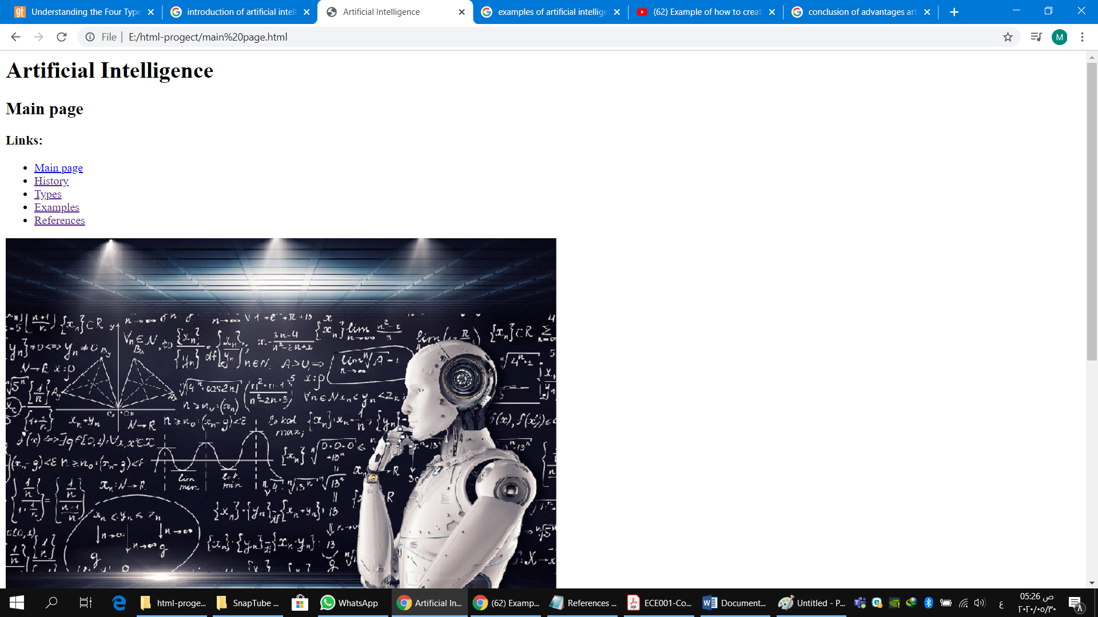

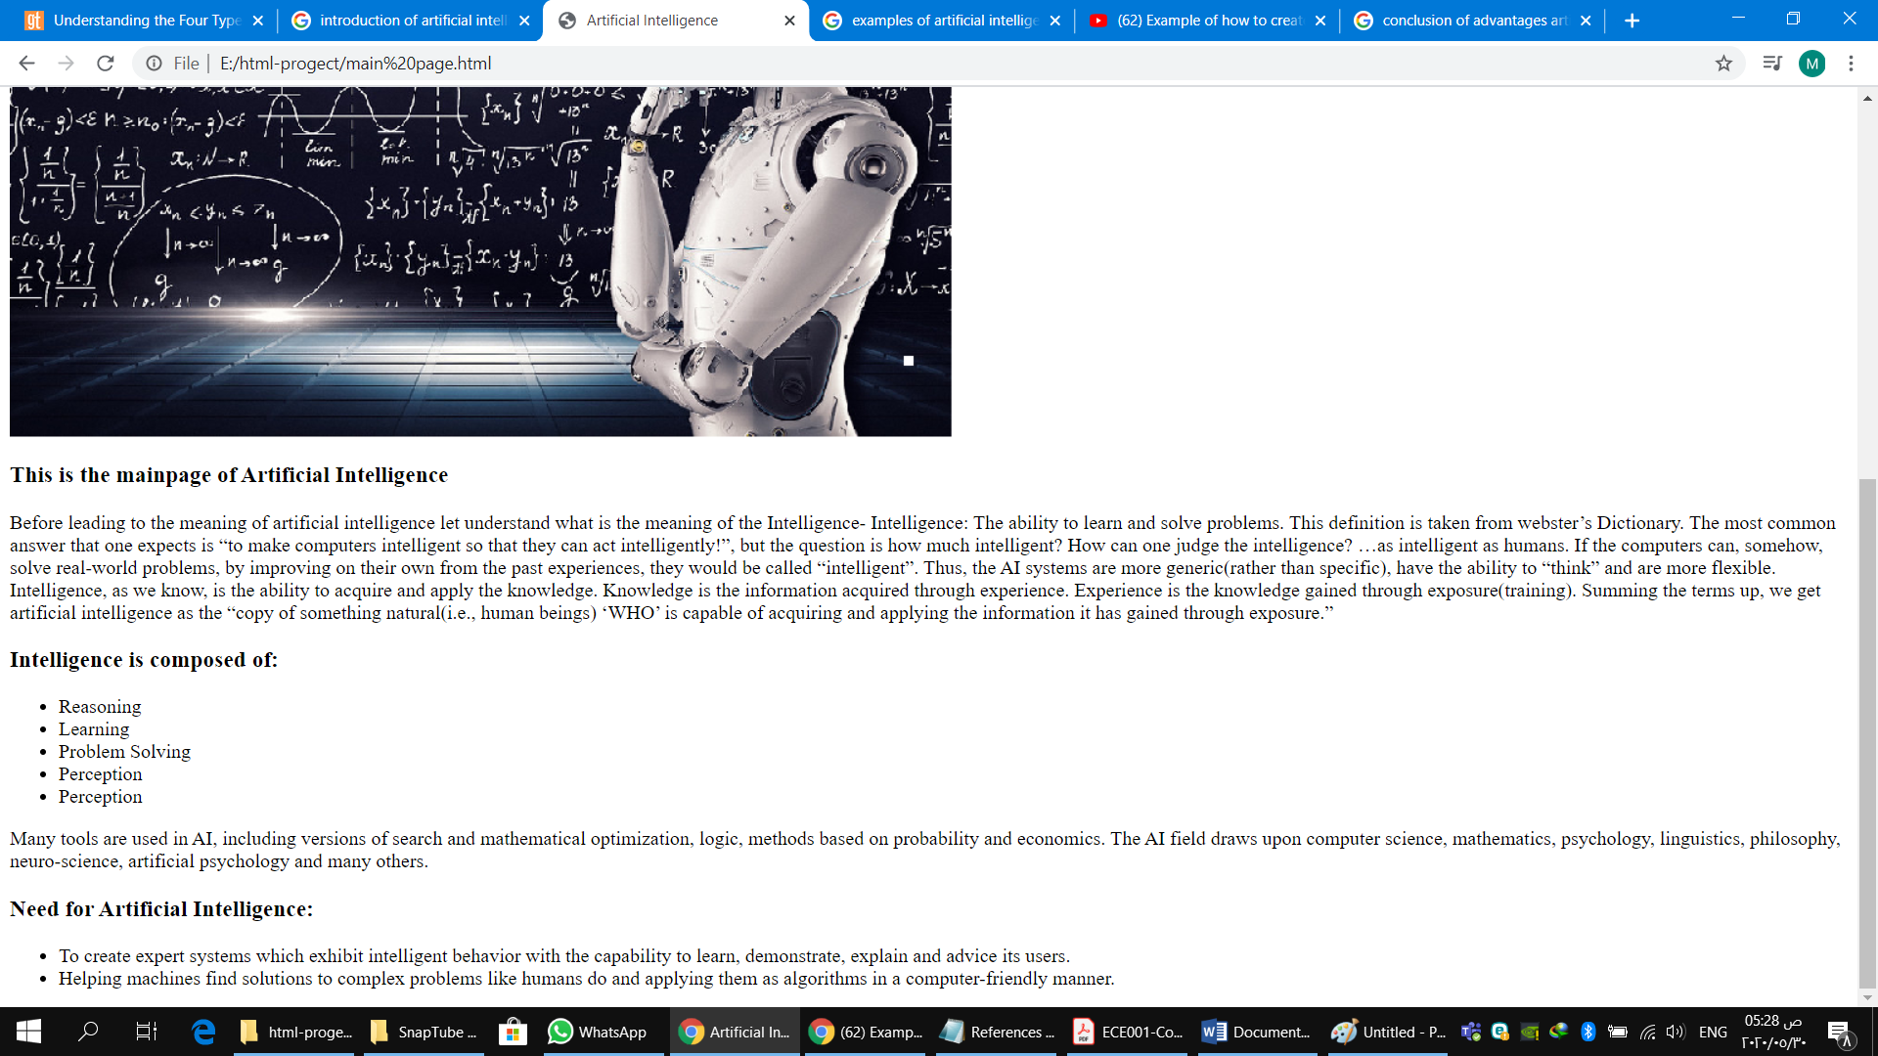

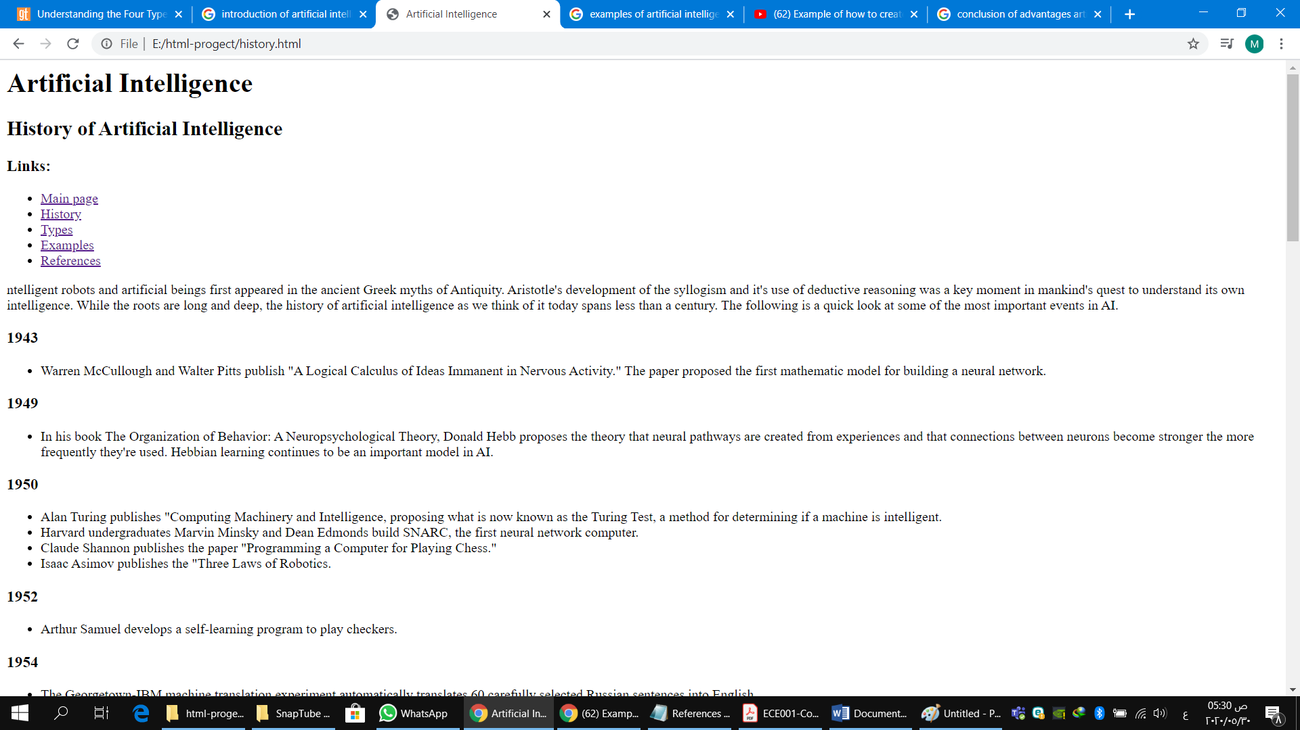

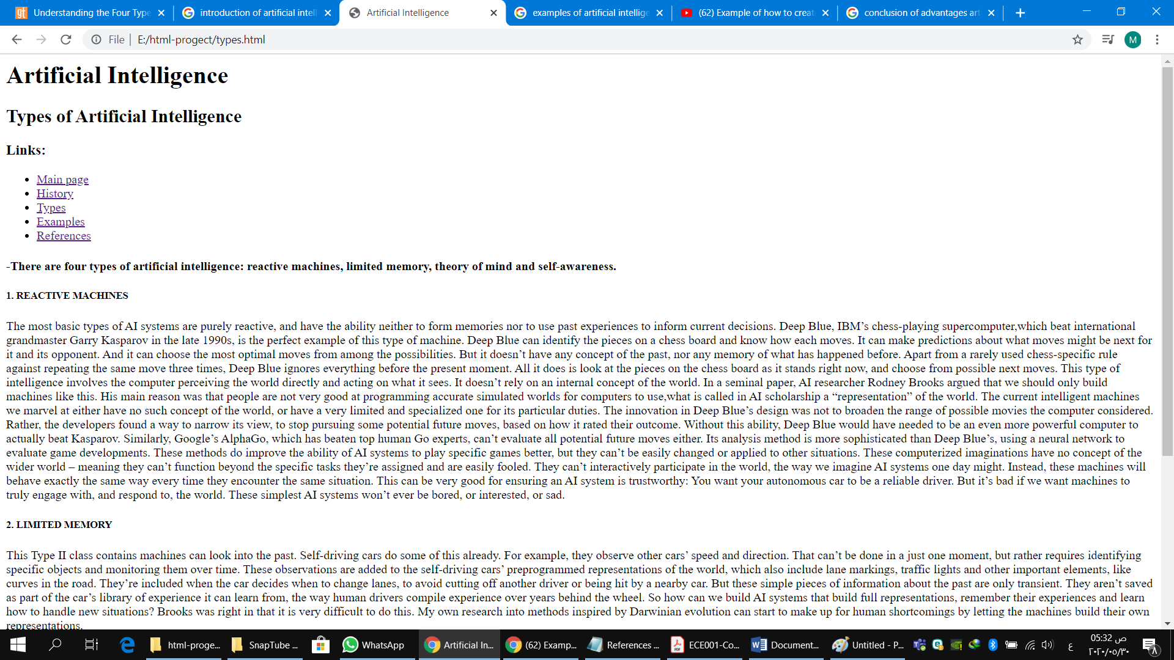

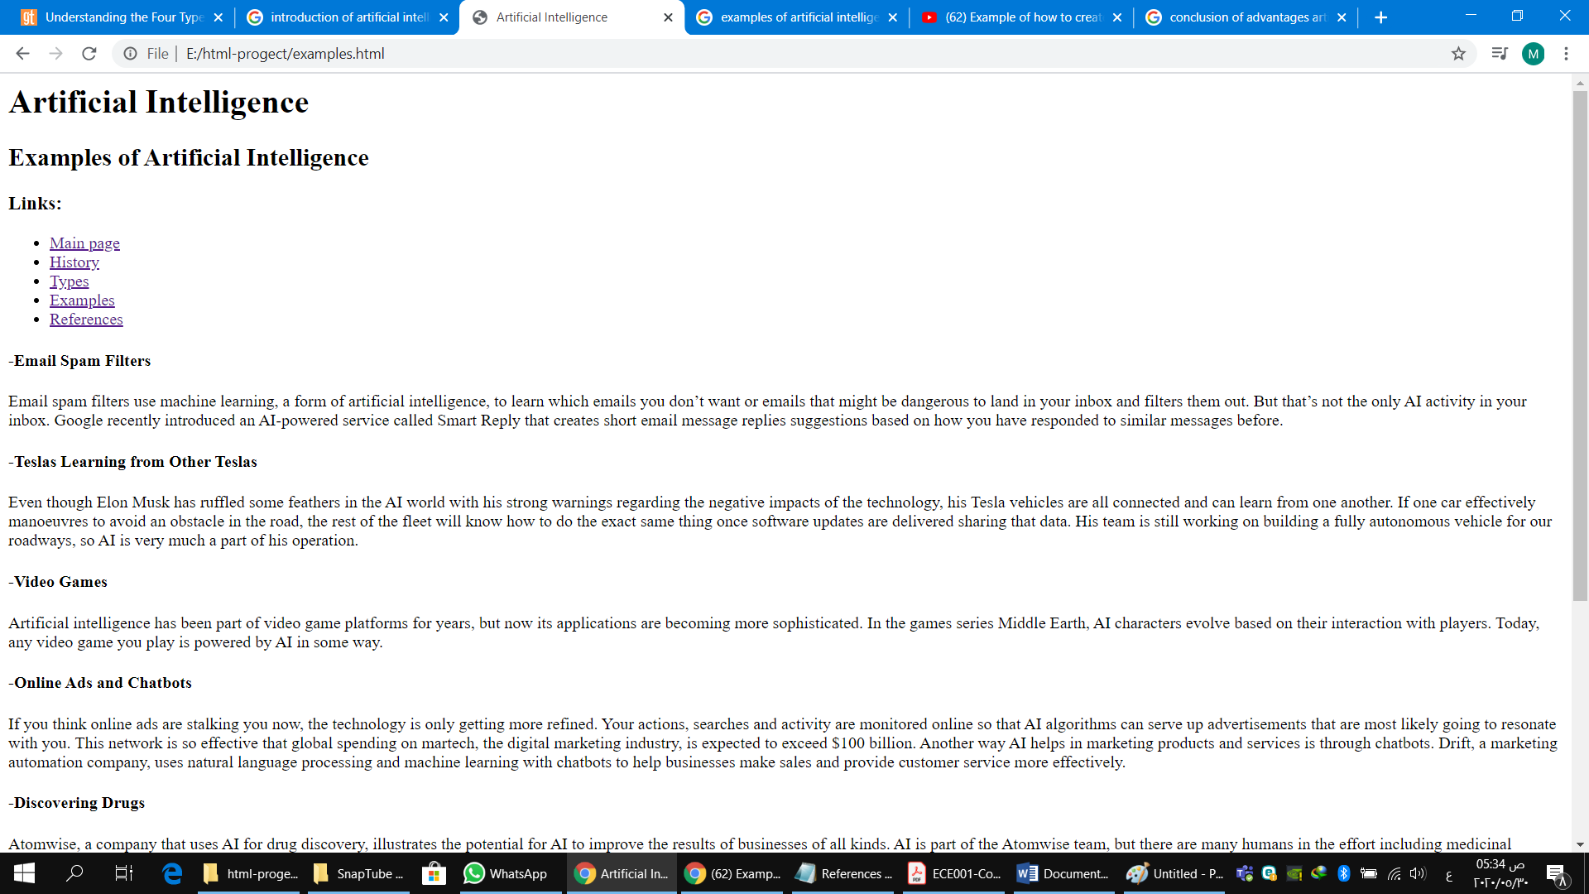

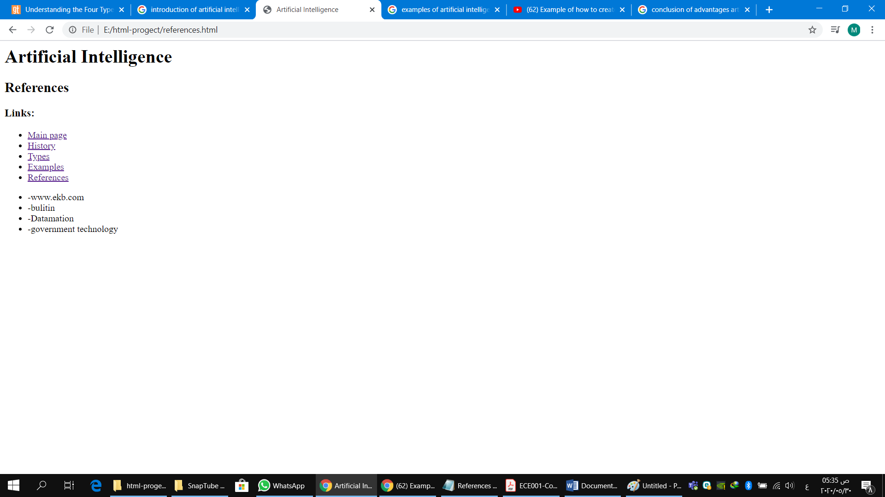

source code:-



